Texas Toolkit – Braden Haley / Katherine Wiley

Transitions to wellbeing
Intentional design practice in school buildings minimizes stressors and improves cognitive function

Introduction
Each year as summer turns to fall, young children step inside a school for the first time, marking a celebrated milestone in the journey to adulthood. Attending school for the first time can be a challenging experience for a child. In particular, the transition from a familiar and safe home life to an unfamiliar and sometimes institutional-feeling school can be an impediment to growth.

New surroundings, routines, and relationships can be overstimulating. Studies show that feeling safe and secure is an essential requirement for learning and development to happen. With this awareness in mind of the psychological impact design has on building users, how can we craft early childhood environments that welcome, comfort, and inspire?

As designers, we strive to create sanctuaries where new learners can flourish, discovering and developing their potential. Design should balance the tangible elements – scale, shape, color, and texture – with features that transcend a physical description – biophilic connections, acoustical design, and sunlight – that shape a child’s sensory experience.

Consider a young student’s transition from home to school – often school buildings can be cold, institutional places, featuring sharp edges and intense colors, a jarring contrast between the warm and comforting home environment that typically includes natural materials like wood and fabrics in comfortable color palettes and textures. It can be stressful when entering a space for the first time and encountering an environment that feels disconnected from the home environment. Biologically there’s something evolutionary in the way we see sharp lines and corners that puts us on edge, but intentionally including some gentle curves in the design, such as biophilic wall coverings or curved shapes in the flooring as you round a corner, can have a pleasing and calming effect on the brain.

Scale and Soothing Spatial Geometry Can Enhance Learning
At a functional level, it is important to remember that the eye level and arm reach of a small child is much different than that of an average-sized adult. This consideration should inform the selection and placement of the physical elements the child interacts with. For example, a windowsill placed lower on the floor might allow a small child to benefit from the view.

The scale of rooms and spaces should also be considered. An unusually long hallway or an overly large, cavernous space has the effect of making small children feel lost and unfamiliar with their surroundings.

The psychology behind shape suggests that the human brain associates sharp angles with alertness and potential threats, while curving shapes, which occur more naturally in nature, convey safety and approachability. The principle of biophilia is not new, and there are many ways in which we can introduce it into our spaces, lighting shapes, furniture shapes, and materiality. Research suggests that curved forms are consistently rated as more pleasing and less threatening (Bar & Neta, 2007). These forms can help soften the interior environment and possibly create intuitive emotional cues.

This idea is reinforced by developing psychology studies. In (Martin & Ochsner, 2016) the systems in the brain responsible for emotion and regulation – particularly the prefrontal cortex – mature more slowly than the reactive emotion centers, such as the amygdala. As a result, children can be more sensitive to environmental stressors and have fewer tools to self-regulate. Since heightened emotional states can impair attention and learning, spatial environments that help to reduce stress and perceived threats can support a child’s emotional regulation and cognitive learning functions. Here is where environmental cues can help: soft shapes and soothing spatial geometry can support feelings of emotional safety by acting as a nonverbal, co-regulatory tool in spaces. These small spatial gestures can make a big difference if they calm the nervous system and allow the cognitive learning process to function more effectively.

This idea can be explored in Pfluger’s design for Hidden Lake Elementary School. In the shared learning space, organic moss-like seating elements invite play and comfort. Their soft, rounded forms serve as whimsical visual anchors but also as tactile, grounded places for rest or play. Overhead large, curved LED light fixtures mimic natural forms – the soft seat below helping to unify the space visually. All together, these elements transform the learning environment into one that is emotionally accessible and engaging.
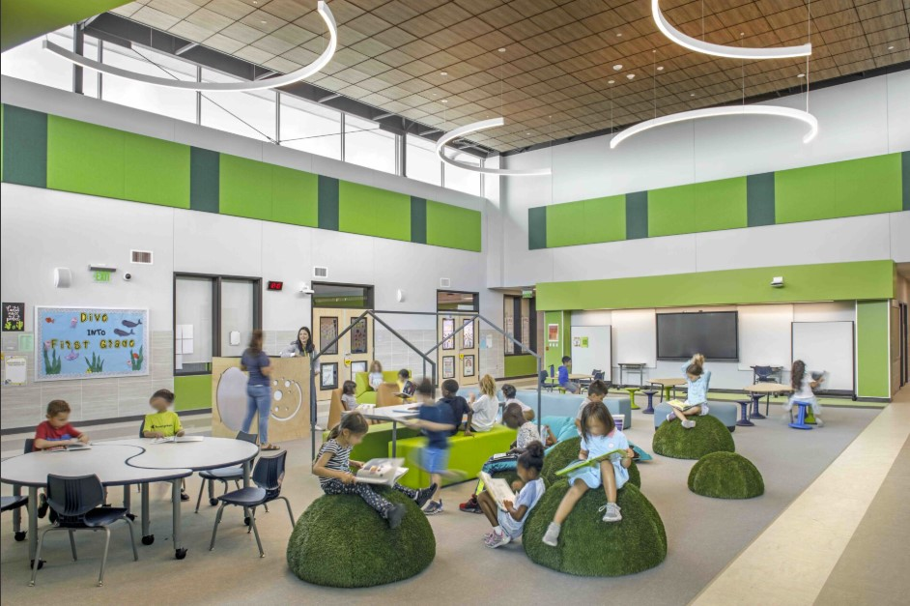
Shared Learning – Hidden Lake ES – Pfluger Architects, 2023

Bar, M., & Neta, M. (2007). Visual elements of subjective preference modulate amygdala activation. Neuropsychologia, 45(10), 2191–2200. https://doi.org/10.1016/j.neuropsychologia.2007.03.017
Martin, R. E., & Ochsner, K. N. (2016). The neuroscience of emotion regulation development: Implications for education. Current Opinion in Behavioral Sciences, 10, 142–148. https://doi.org/10.1016/j.cobeha.2016.06.006
Vartanian, O., Navarrete, G., Chatterjee, A., Fich, L. B., Leder, H., Modrono, C., ... & Skov, M. (2013). Impact of contour on aesthetic judgments and approach-avoidance decisions in architecture. Proceedings of the National Academy of Sciences, 110(Supplement_2), 10446–10453. https://doi.org/10.1073/pnas.1301227110

Color is Cultural
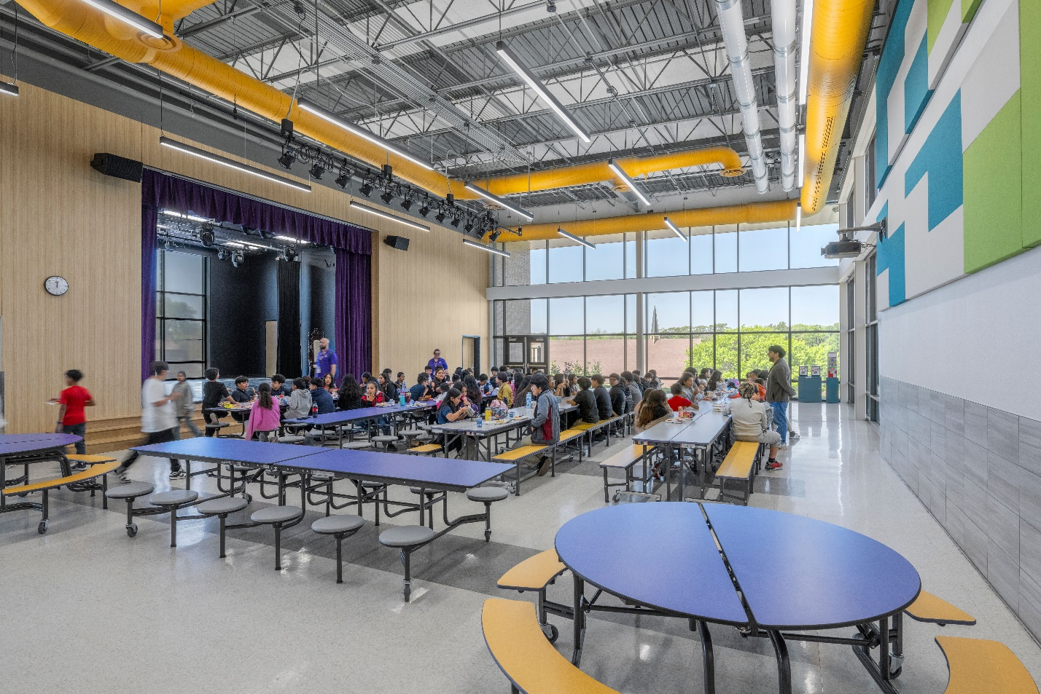
Color Tuning a Cafeteria – George Peabody ES – Pfluger Architects, 2024

Color can play a profound role in shaping a child’s sensory perception and emotional response, which is crucial when designing environments for learning and supporting cognitive development. While vibrant, highly saturated hues can energize a space, research indicates that an overabundance or poor coordination of colors, along with large quantities of patterning can overstimulate children, especially those with sensory sensitivities (Maule, Skelton, & Franklin, 2023).

We can use color when designing for belonging; color can reflect culture and help us acknowledge home environments. For example, historically in the United States, red has been associated with signals such as “stop” or “alarm.” Research indicates that red can contribute to eye strain and irritability in specific contexts, particularly under prolonged exposure (Elliot & Maier, 2014; Küller, Mikellides, & Janssens, 2009). Conversely, a study on Japanese elementary and high school students revealed a preference for red (Imai et al., 2020), underscoring the cultural influence on color preferences. Therefore, when designing spaces for children, to cultivate a feeling of belonging it is essential to consider context – and what “home” means for those students. In the case of George Peabody Elementary School in Oak Cliff, colors were used as accents in an energized space like the cafeteria. The selected hues – purple, yellow, green, and blue – align with the top preferences for children while the remainder of the space remains neutral. With enhanced natural daylighting, the colors activate the environment without creating visual overwhelm (Glogar, Kašparová, & Máchová, 2017; Maule et al., 2023).

Elliot, A. J., & Maier, M. A. (2014). Color psychology: Effects of perceiving color on psychological functioning in humans. Annual Review of Psychology, 65, 95–120. https://doi.org/10.1146/annurev-psych-010213-115035
Glogar, P., Kašparová, J., & Máchová, P. (2017). Preferences of colors and importance of color in working surrounding of elementary school children. In INTED2017 Proceedings (pp. 6578–6585). IATED. https://library.iated.org/view/GLOGAR2017PRE
Imai, M., Saji, N., Große, G., Schulze, C., Asano, M., & Saalbach, H. (2020). General mechanisms of color lexicon acquisition: Insights from comparison of German and Japanese speaking children. In Proceedings of the 42nd Annual Conference of the Cognitive Science Society (pp. 3315–3321).
Küller, R., Mikellides, B., & Janssens, J. (2009). Color, arousal, and performance – A comparison of three experiments. Color Research & Application, 34(2), 141–152. https://doi.org/10.1002/col.20476
Maule, J., Skelton, A. E., & Franklin, A. (2023). The development of color perception and cognition. Annual Review of Psychology, 74, 87–111. https://doi.org/10.1146/annurev-psych-032720-040512
Additional notes from 2024 NeoCon talk “20 Things Neuroscientist Wants You to Know”
By Dr. Sally Augustin, Design with Science

Acoustics for Positive Learning Outcomes
Acoustical quality is an important but often overlooked school design factor that directly impacts student learning outcomes and teacher effectiveness. Poor acoustics inside classrooms negatively affect the teaching and learning processes, especially at the lowest grades of education, making proper acoustical design critical for younger students who are developing foundational learning skills. Suitable acoustical design in classrooms and other learning spaces enhances speech clarity and limits background noise to protect speech quality for both the teacher and student. Higher speech intelligibility results in a positive effect on learning outcomes.

The measurable benefits extend beyond academic performance to encompass behavioral and health outcomes. Studies have shown that following improvements to classroom acoustics, teachers have reported higher student engagement and improved results in on-task behavior.

Acoustic design strategies include:
Design in acoustic buffer zones between noise sensitive classrooms and areas prone to higher activity and noise levels.
Reduce reverberation in learning spaces by use of soft and sound-absorbing materials such as rugs, fabric curtains, cork boards, and acoustical wall or ceiling panels.
Add soft tips or pads to the bottom of tables and chairs.
Add a speech-reflective zone above the teacher's presentation area for passive audio distribution.
Add an audio distribution system, including teacher microphone and distribution speakers.

Materials in a safe and welcoming space should evoke comfort, not just durability. Sometimes a home or school is a first sanctuary space – how can we create spaces that are filled with soft, tactile, natural materials like wood, fabric, and warm colors? In the past, institutional buildings trended toward hard, cold finishes that felt alienating. Studies in environmental psychology indicate that children have strong tactile sensitivity, and overly sterile environments could provoke unease (Evans, 2006).

The design of Dorothy Martinez Elementary School challenged that paradigm. In the school’s dining and gathering space, a mix of materials creates an experience that feels both functional and emotionally grounded. Warm-toned wood-looking luxury vinyl tile is used, balancing the acoustic ceiling tiles designed to absorb excess sound – a vital feature in large active spaces. Tall, wooden slat panels with felt backing provide acoustic treatment as well and physically warm the double-height volume space, while floor materials subtly shift in tone and texture to define space without overwhelming it. The effect is inviting and sensory aware.

Materiality also affects what we hear and how we feel. According to (Christenson,2018), poor acoustics can be a barrier to learning, increasing cognitive load and making speech harder to understand. This influences an emphasis on using sound absorbing materials to help quiet a room while creating a warm, grounded auditory landscape where children can flourish. 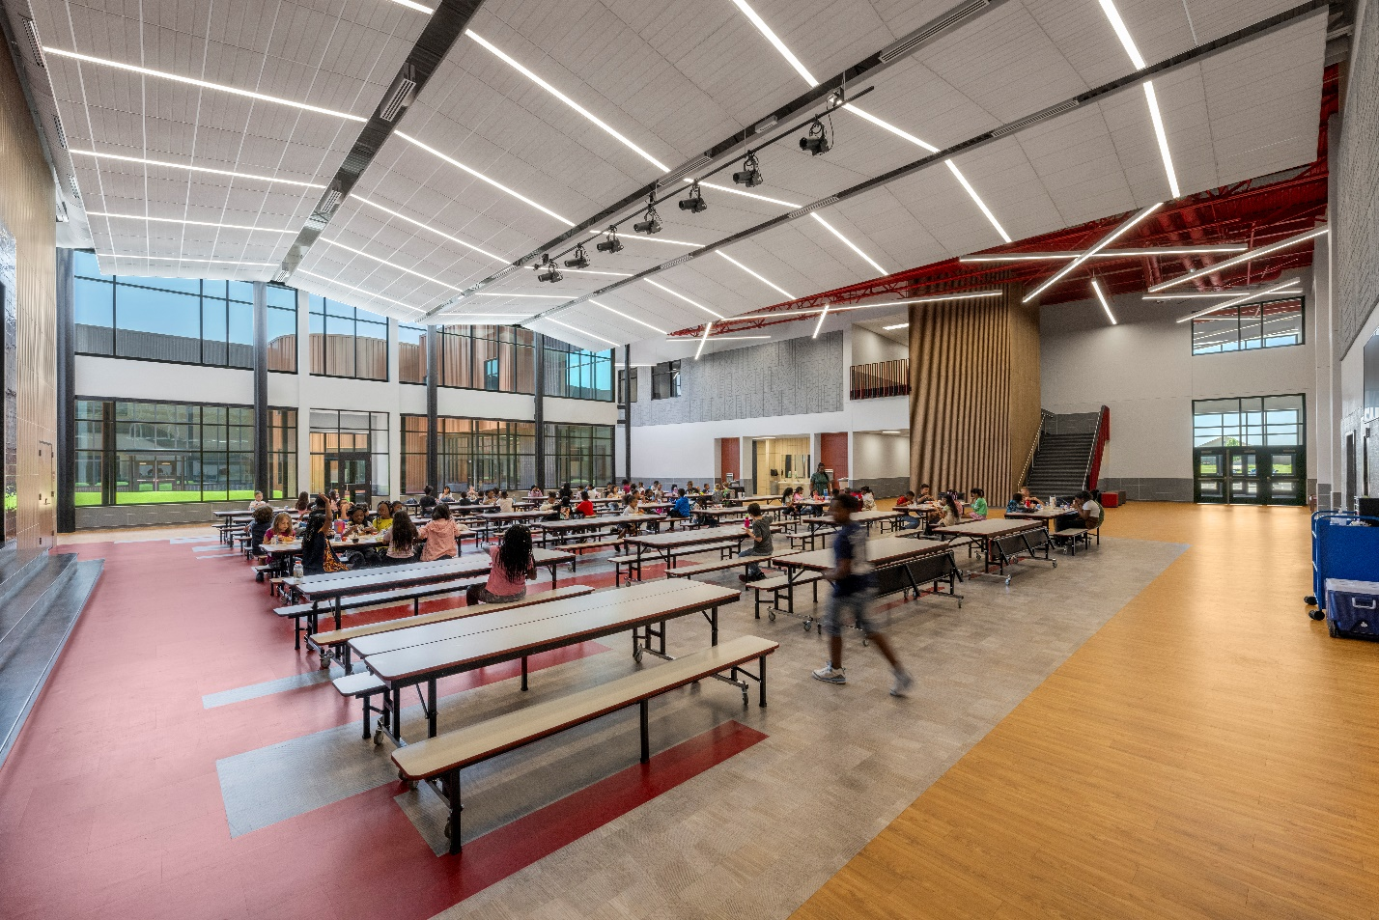
Gathering Space – Dorothy Martinez ES – Pfluger Architects, 2024

• Christensson, J. (2018). Good acoustics for teaching and learning. Euronoise 2018 Conference Proceedings, 1755–1759. https://www.researchgate.net/publication/326096680
• Evans, G. W. (2006). Child development and the physical environment. Annual Review of Psychology, 57, 423–451. https://doi.org/10.1146/annurev.psych.57.102904.190057

Lighting Design
Lighting design serves as a fundamental environmental factor in early childhood learning spaces, directly influencing children’s physical development, cognitive abilities, and overall learning experience.

Research demonstrates that exposure to appropriate lighting can improve concentration, enhance cognitive abilities, and regulate sleep patterns. Conversely, poor lighting can lead to irritability, restlessness, eye strain, and difficulty with focus and attention.

The benefits of natural daylight are significant for young learners, as increased light during the daytime is broadly associated with beneficial effects on social-emotional, cognitive, and physical health outcomes. Exposure to bright light may significantly increase the brain's ability to grow new pathways and retain information. Bright light boosts mood and concentration, which is crucial for maintaining young children’s engagement during learning activities.
Lighting solutions should support both developmental needs and educational objectives in early childhood settings.

Connection to Nature
The integration of natural elements and biophilic design principles in early childhood learning facilities provides substantial developmental and educational benefits that extend across multiple domains of child growth.

Studies have shown that exposure to nature has may benefits including social development, better concentration, increased short-term memory and reduced stress. Connections with nature can also engage the senses and spark young learners’ curiosity.

When it comes to incorporating biophilic elements in the design of schools and early childhood learning there are several strategies:
Biophilic and natural elements can be incorporated into interior environments and learning spaces through plants and living walls.
Provide views to outdoor natural areas.
Provide direct access to outdoor areas, courtyards, playgrounds, sensory gardens and growing gardens.

Sources:
Importance of acoustical design in learning environments
Effects of Classroom Acoustics on Performance and Well-Being in Elementary School Children: A Field Study (Research Publication)
Klatte, Hellbruck, Seidel, & Leistner, 2010.
Acoustical Design in Education: Creating the Perfect Learning Environment (Web Publication)
Kireiusa.com
Influence of Classroom Acoustics on Noise Disturbance and Well-Being for First Graders
Astolfi, 2019
Importance of lighting design in learning environments
Turning on the light. Thinking about Lighting Issues in Child Care.
Alexander, 2008
The importance of Good Lighting in Child-Friendly Spaces (Web Article)
Reed, 2023
The effects of light in children; A systematic review
Westwood, 2023
Lighting in Early Childhood Environment (Research Publication)
Shivarama, 2014
Importance of connections to nature
Take it Outside; A History of Nature-Based Education
Prochner, 2021
Nature-Based Learning: Why it’s Essential in Early Childhood (Web Publication)
International School Ho Chi Minh City. Ishcmec.com
Biophilic Design: Why Biophilia in Education gets an A+ (Web Publication)
Inprocorp.com, 2020

Emotions shape learning
Children can arrive at school in different emotional modes, and emotional loads can vary. Some can experience nerves, and others could be overstimulated from the transition from home to school environments. Design that accounts for this range of emotions could offer pathways toward self-regulation. Thoughtful spatial programming that accommodates this emotional diversity is essential in cultivating emotional regulation and feelings of internal safety. Recent journals on education neuroscience emphasize the important of autonomy, transition, and environmental cues in supporting a child’s emotional development (Immordino -Yang, 2015).

Design can create zones of refuge – allowing students to find the sensory input or calm they need in the moment. This aligns with research showing that emotional safety is a prerequisite for executive function and self-regulation – critical components of learning to read (Blair & Rave, 2015).

This principle is beautifully explored at Dorothy Martinez and Braeburn Elementary Schools, where quiet nooks and pods are embedded into the building. Bold sculptural reading pods were created at Dorothy Maritnez Elementary School, while dome-like sensory alcoves at Braeburn Elementary School offer enclosures that support withdrawal and emotional recalibration. These carved-out sanctuaries invite quiet focus or co-regulation among peers. They are not just playful moments in the interior architecture – they reflect how built environments could include brain networks responsible for regulation and cognitive control (Barrett & Satpute, 2013).

Positioning these nooks in activated areas and circulation zones means that children don’t have to travel too far to access these environmental tools. They can help support self-direction while reducing emotional and physical fatigue – important for younger learners who may be overwhelmed by longer transitions.
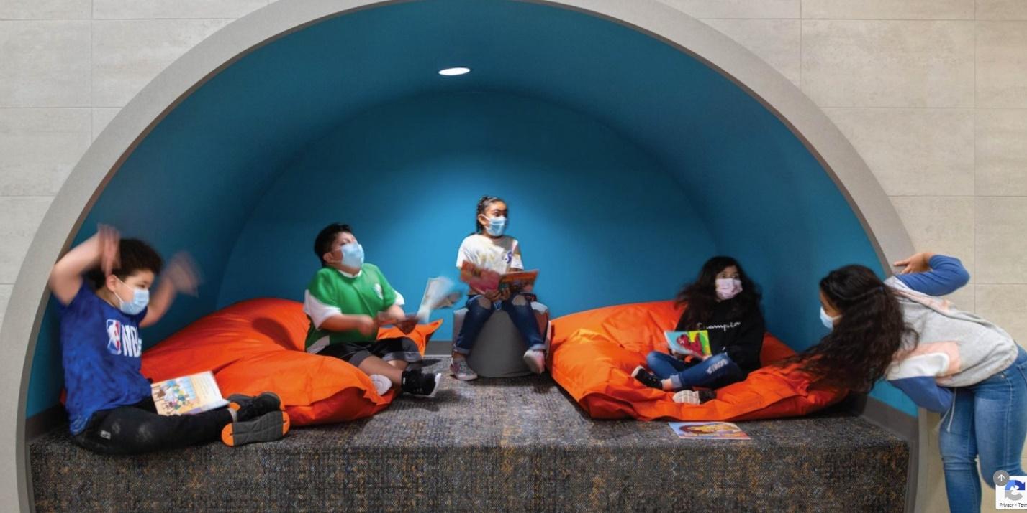
Sensory Alcove – Braeburn ES – Pfluger Architects, 2020
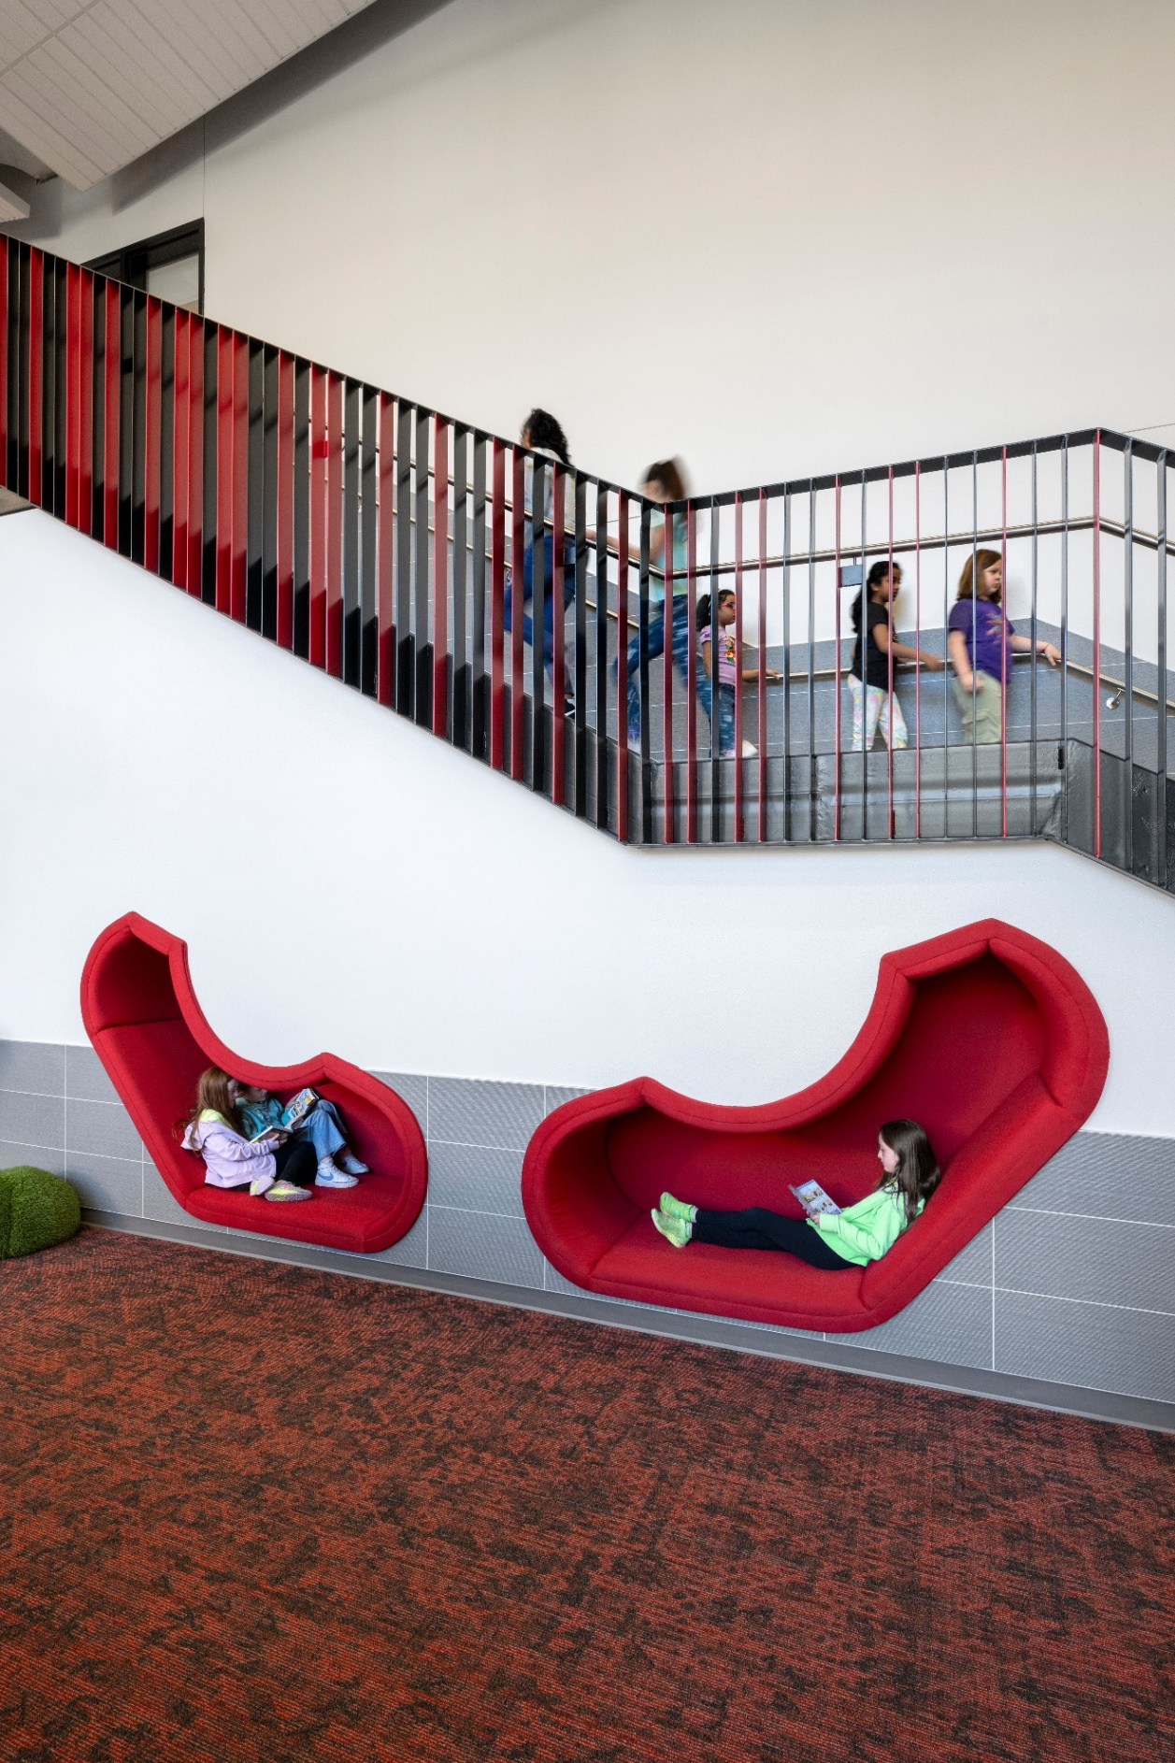
Media Center Reading Pods – Dorothy Martinez ES – Pfluger Architects, 2024

Barrett, L. F., & Satpute, A. B. (2013).
Barrett, L. F., & Satpute, A. B. (2013). Large-scale brain networks in affective and social neuroscience: Towards an integrative functional architecture of the brain. Current Opinion in Neurobiology, 23(3), 361–372. https://doi.org/10.1016/j.conb.2012.12.012
Blair, C., & Raver, C. C. (2015).
Blair, C., & Raver, C. C. (2015). School readiness and self-regulation: A developmental psychobiological approach. Annual Review of Psychology, 66, 711–731. https://doi.org/10.1146/annurev-psych-010814-015221

Creating a safe and welcoming environment can have a profound impact on our wellbeing, improving cognitive functions and opening the doors for better learning outcomes. Intentionally designed spaces and the transitions between allow every person to experience wellbeing and access emotional regulation and safety within their space. School buildings in particular can be a relief or a sanctuary, a place where stressors are minimized for students and cognitive functions are enhanced, all a result of thoughtful, empathetic design.
A designer’s conscious use of scale, color selection, visibility to the outdoors and natural light, all play a role in reducing anxiety of moving from space to space.

About the authors:
Braden Haley
Katherine Wiley

About Pfluger Architects
Pfluger Architects is a premier Texas-based architecture firm with extensive experience in educational facility planning, design, and construction administration. Named one of Building Design + Construction’s Top 50 Architecture Firms in the 2024 Top 200 List, including the Top 10 K-12 Architecture Firms List, Pfluger Architects partners with communities and institutions to create engaging learning environments. Pfluger’s inclusive and collaborative teams across five Texas locations create beautiful, functional, environmentally sensitive spaces that inspire clients and communities to create meaningful human experiences. Learn more at https://pflugerarchitects.com/.

